Table of Contents

- System Features 3
  - User Authentication 3
  - Course Management 4
  - Course Registration and Timetable Generation 4
  - Reports and Administration 4
- Functional Requirements 5
  - Use Case Diagram 5
- Use Case Description 6
- Appendix A: Glossary 21

System Features

User Authentication

    - Description and Priority
Allows users to log in securely (High priority).
    - Stimulus/Response Sequences
User enters credentials → System verifies → Redirects to appropriate dashboard.
    - Functional Requirements
      - FR-1: System shall allow students and admins to log in.
      - FR-2: System shall encrypt passwords using SHA or equivalent.

Course Management

    - Description and Priority
Admin manages course catalog (High priority).
    - Stimulus/Response Sequences
Admin selects “Add Course” → Enters details → Data stored in DB.
    - Functional Requirements
      - FR-3: Admin can add, edit, and delete courses.
      - FR-4: Course codes must be unique.
      - FR-5: Changes must update related timetables instantly.

Course Registration and Timetable Generation

    - Description and Priority
Core functionality for students (High priority).
    - Stimulus/Response Sequences
Student selects available course → System checks clash → Adds if valid.
    - Functional Requirements
      - FR-6: Students can register or drop courses.
      - FR-7: System shall detect and prevent timetable clashes.
      - FR-8: System shall display generated timetable in grid format.

Reports and Administration

    - Description and Priority
Admin can generate and export reports (Medium priority).
    - Functional Requirements
      - FR-9: System shall generate registration summary reports.
      - FR-10: Reports shall include total seats, occupancy, and timetable stats.

Functional Requirements

Use Case Diagram

The following Use Case Diagram provides a visual representation of how the Student and Administrator interact with the Course Registration and Timetable Scheduler system.

Actors:
    - Student: Registers, drops courses, and views timetable.
    - Administrator: Manages courses, users, and generates reports.
Use Cases:
- Login
- Manage Courses
- Registration of courses
- Drop Course
- View Timetable
- Generate Timetable
- Generate Reports
- Logout
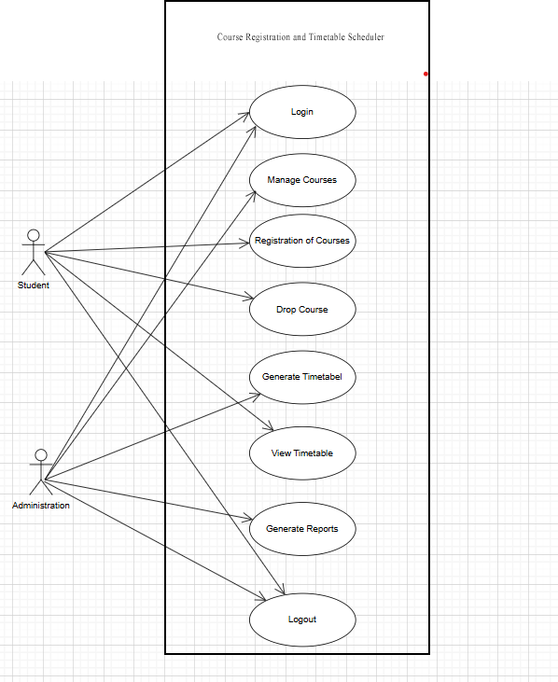

Figure 1: Use Case Diagram – Course Registration and Timetable Scheduler

Use Case Description
Use Case ID: UC1 Use Name: Login
Scope: Course Registration and Timetable System
Level: User-goal
Primary Actor: Student / Admin Stakeholders & Interests
- Student/Admin: Wants quick and secure access to the system.
- System: Verifies only valid users enter and maintains security of user accounts.
Preconditions
- User must have a valid registered account.
Success Guarantee (Postconditions)
- User is successfully authenticated and redirected to the dashboard.
Main Success Scenario
- User opens the login page.
- User enters username and password.
- System validates the credentials.
- System grants access.
- System redirects user to the dashboard.
Extensions
  - 3a. Invalid Credentials:
    - System shows “Invalid username/password.”
    - User re-enters credentials.
  - 2a. Missing Fields:
    - System prompts user to fill required fields.
Special Requirements
  - Password should be encrypted during transmission.
  - Login should occur within 2 seconds.
Technology & Data Variations
  - 2a. Users may log in using email or username.
  - 3a. Two-factor authentication may be enabled.
Frequency of Occurrence

  - Many times daily.
Open Issues
  - Should system support biometric login?
  - Should the system lock accounts after repeated failures?

Use Case ID: UC2 Use Name: Logout
Scope: Course Registration and Timetable System
Level: User-goal
Primary Actor: Student / Admin Stakeholders & Interests
  - User: Wants to exit securely.
  - System: Ensures sessions are fully terminated.
Preconditions
  - User must be logged in.
Success Guarantee
  - System clears the session and shows the login page.
Main Success Scenario
- User clicks Logout.
- System clears session.
- System redirects to the login page.
Extensions
  - None.
Special Requirements
  - Session must be destroyed server-side.
Technology Variations
  - Auto-logout after inactivity.
Frequency
  - Several times daily.
Open Issues
  - Should system offer “Remember me”?

Use Case ID: UC3
Use Name: Manage Courses
Scope: Course Registration and Timetable System
Level: User-goal Primary Actor: Admin Stakeholders & Interests
  - Admin: Wants to manage course offerings.

  - Students: Want accurate course listings.
Preconditions
  - Admin is logged in.
Success Guarantee
  - Course list is updated accurately.
Main Success Scenario
- Admin opens Manage Courses.
- Admin selects add/edit/remove.
- Admin enters course details.
- System validates.
- System saves changes.
- System updates course list.
Extensions
  - 4a. Invalid Data:
System shows error message.
  - 2a. Course cannot be deleted (students registered):
System prevents deletion and shows message.
Special Requirements
  - Course ID must be unique.
Technology Variations
  - Admin may upload course details through CSV.
Frequency
  - Weekly or at semester start.
Open Issues
  - Should admin be allowed to archive instead of delete?

Use Case ID: UC4
Use Case Name: Register Courses
Scope: Course Registration and Timetable System
Level: User-goal Primary Actor: Student Stakeholders & Interests
  - Student: Wants to register courses without conflicts.
  - System: Ensures seat availability and prevents clashes.
Preconditions
  - Student is logged in.

  - Course list exists.
Success Guarantee
  - Student is successfully registered for selected courses.
Main Success Scenario
- Student opens Registration page.
- Student views available courses.
- Student selects courses.
- System checks prerequisites.
- System checks seat availability.
- System checks timetable conflicts.
- System registers student.
- System updates student’s schedule.
Extensions
  - 4a. Missing prerequisites → System displays error.
  - 5a. No seats available → System shows “Class Full.”
  - 6a. Time conflict → System warns user.
Special Requirements
  - Real-time seat availability update.
Technology Variations
  - Courses may be displayed in list or calendar format.
Frequency
  - Once or twice per semester.
Open Issues
  - Should system auto-suggest alternate courses?

Use Case ID: UC5
Use Case Name: Drop Course
Scope: Course Registration and Timetable System
Level: User-goal Primary Actor: Student Stakeholders & Interests
  - Student: Wants flexibility to adjust schedule.
  - System: Maintains accurate registration counts.
Preconditions
  - Student is logged in.

  - Student is already registered for the course.
Success Guarantee
  - Course is removed from student schedule.
Main Success Scenario
- Student opens Registered Courses.
- Student selects a course to drop.
- System removes course.
- System updates registration count.
- System updates timetable.
Extensions
  - 2a. Deadline passed → System refuses and shows message.
Special Requirements
  - System must enforce drop deadlines.
Technology Variations
  - Student may drop via web or mobile app.
Frequency
  - Rare (1–2 times per semester).
Open Issues
  - Should refund policy be integrated?

Use Case ID: UC6
Use Case Name: Generate Timetable
Scope: Course Registration & Timetable System
Level: Summary
Primary Actor: Admin Stakeholders & Interests
  - Student: Wants a conflict-free schedule.
  - System: Must auto-generate optimized timetable.
Preconditions
  - Admin must be registered in at least one course.
Success Guarantee
  - Valid timetable is generated without conflicts.
Main Success Scenario
- Admin clicks Generate Timetable.
- System gathers registered courses.
- System processes available times.

- System resolves conflicts.
- System generates timetable.
- System displays it to the student.
Extensions
- 4a. Conflicts cannot be resolved → System displays unresolved clashes.
Special Requirements
- Processing time under 3 seconds.
Technology Variations
- Calendar view or list view display.
Frequency
- Several times during registration week.
Open Issues
- Should user be allowed to customize preferences?

Use Case ID: UC7
Use Case Name: View Timetable
Scope: Course Registration and Timetable System
Level: User-goal Primary Actor: Student Stakeholders & Interests
- Student: Wants easy access to weekly schedule.
Preconditions
- Timetable must be already generated.
Success Guarantee
- Timetable is displayed successfully.
Main Success Scenario
- Student opens “View Timetable.”
- System retrieves timetable.
- System displays it.
Extensions
  - 1a. No timetable exists → System asks student to generate one.
Special Requirements
  - Compatible with mobile view.
Technology Variations
  - Display in grid, table, or calendar.
Frequency
  - Daily.

Open Issues
  - Should system support exporting to PDF?

Use Case ID: UC8
Use Case Name: Generate Reports
Scope: Course Registration and Timetable System
Level: Summary
Primary Actor: Admin Stakeholders & Interests
  - Admin: Needs analytics for decision-making.
  - University: Wants accurate enrollment records.
Preconditions
  - Admin is logged in.
Success Guarantee
  - Report is generated and displayed/exported.
Main Success Scenario
- Admin selects “Generate Reports.”
- Admin selects report type.
- System processes data.
- System generates report.
- System presents report.
Extensions
  - 3a. Data missing → System warns admin.
  - 4a. Report too large → System offers download option.
Special Requirements
  - Report download in PDF/Excel.
Technology Variations
  - Chart-based or table-based report formats.
Frequency
  - Monthly or end of semester.
Open Issues
  - Should system automate scheduled report emails?

Appendix A: Glossary

Term | Definition
GUI | Graphical User Interface
DBMS | Database Management System
JDBC | Java Database Connectivity
FR | Functional Requirement
NFR | Non-Functional Requirement
MVC | Model-View-Controller Design Pattern

